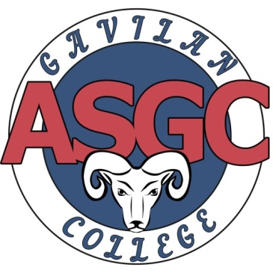
$200 TEXTBOOK SCHOLARSHIP
Download an application from the ASGC website at www.gavilan.edu/student/asgc

To qualify, submit a copy of your:
- Class schedule demonstrating that you are enrolled in at least six (6) academic units at Gavilan College
- Transcript indicating a cumulative GPA of 2.5 or above; new students do not need GPA.
- Receipt showing that you have paid for your classes AND your ASGC card in full
- Current Educational Plan completed by a Gavilan College Counselor OR Degree Works degree audit that indicates that the classes you are enrolled in are necessary to meet your academic goal.
Type a one to two-page personal statement answering the following questions:
- What are your future goals?
- How will this scholarship benefit you in reaching your goals?
- Why should we choose you as the recipient of this scholarship?

Deadline: Wednesday August 15th at 4pm in the Welcome Center of the Gilroy Campus or the Hollister, Morgan Hill, or Coyote Valley Sites.

For more information, please contact:
- Dr. Blanca Arteaga, ASGC Advisor barteaga@gavilan.edu
- Ryan Shook, Student Life Coordinator rshook@gavilan.edu

